



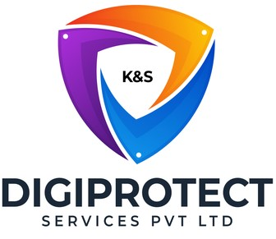
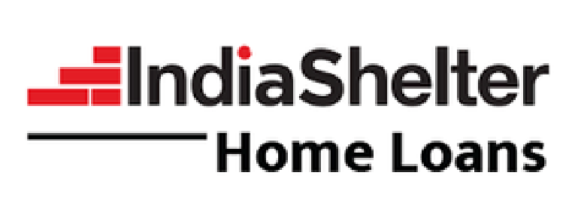
INITIAL
ASSESSMENT
REPORT
DATE: 28th May 2024
Customer Care

VERSION: 1.1

Document History
Document version | Remarks | Submitted  By | Submission  Date | Approved BY | Approval  Date
1.0 | First Draft | k&S Digiprotect | 17th May 2024
1.1 | Second Draft | k&S Digiprotect | 28th May 2024

Table of Contents
Introduction 4
Objectives 4
General Information 5
SPOC Information 5
Department Hierarchy* 6
Key Processes 7
Data Flow Diagram (DFD) 10
Data Mapping and Inventory 11
Recommendations 12
Conclusion 12
Appendices 13
Appendix A 13

Introduction
The Customer Care team specializes in offering assistance and solutions to customers, adeptly handling their inquiries, concerns, and issues pertaining to ISFC’s products. Their primary objectives include maximizing customer satisfaction, swiftly resolving issues, and facilitating seamless communication between customers and the company.
This report encapsulates critical insights for As-Is study, derived from the initial interview conducted with the Customer Care Department of India Shelter Finance Corporation Limited (ISFC) for the implementation of ISO/IEC 27001:2022 and compliance with the Digital Personal Data Protection Act (DPDPA).
The overarching objectives of this interview were dual fold: first, to gain an understanding of the departmental structure, and second, to delve into the core operational processes of the Customer Care Department. Additionally, the interview aimed to assess the existing information security practices, focusing on evaluating adherence to DPDPA requirements and the readiness for ISO/IEC 27001:2022 implementation.
By delving into the details of the department's organizational setup, operational workflows, and data handling procedures, this report aims to identify both the strengths and areas of improvement in information security management and DPDPA compliance within the department.

Objectives
- Understand the departmental hierarchy and reporting structure.
- Learn the existing processes of ISFC’s Customer Care Department.
- Mapping of existing processes with documented processes.
- Offer recommendations to optimize the existing processes.

General Information
Organization Name | India Shelter Finance Corporation Limited
Department Name | Customer Care Department
Date of the Assessment | 30th April 2024
Location | Basement, India Shelter HQ, Gurugram
Meeting Duration | 1 hour
Attendees (ISFC) | Nipun Saini, Jitesh, Sunil Kumar Sharma, Bal Mukund
Attendees (Digiprotect) | Sushil Menon, Adhita Razdan

SPOC Information
Project SPOC: Dheeraj Yadav
Contact Information:
Email ID: dheeraj.yadav@indiashelter.in

Project Coordinator: Sunil Kumar Sharma
Contact Information:
Email ID: sunil.sharma2@indiashelter.in

Department SPOC: Nipun Saini
Contact Information:
Email ID: nipun.saini@indiashelter.in

Department Hierarchy*

* As informed during the meeting

Key Processes
S. No | Key Activities | Observations and Asks | Remarks
 | Channels of Communication  - There are three channels for customers to reach ISFC – Toll free number, WhatsApp, Emails | NA
 | Compliance Calling  - Compliance Calling/Hygiene Calling are of 4 types.  - Questionnaire based information is collected and stored in Excel. This information is transferred to Field Audit & Anti-Fraud team. | - ISFC to explain the process of recording information taken during compliance calling.  - ISFC to explain Cash calling process, along with the definition of old customers.  - ISFC to clarify whether data sharing is done with Compliance team or Field Audit & Anti-Fraud team.  - ISFC to explain the process in case of no contact after 3 attempts with the customer (old/new).  - ISFC to explain what ED stands for and its purpose. | ISFC to share Set script for HLA Calling
 | Customer Care  - Calls from unregistered numbers have 3 IVR workflows:  - If the call is for a new loan, the call is transferred to the Sales team.  - If the call is related to DSA, then the customer is given 2 further options:  - New code  - Payment related inquiry  In both the options, a new case is generated, and update is shared with the client within 2 days.  - If the call is from an existing customer, the customer is asked to call from the registered number.  - Calls from registered numbers are given 6 options in the IVR:  - EMI related queries  - Loan Status  - Insurance  - Subsidy (CLSS)  - Loan Closure & Certificate  - Other Queries (Property papers, complaints, etc)  - The TAT for these queries is 48 hours.  - Calls for Loan Closure & Certificate gets transferred to the Retention team.  - There are 4 Case Categories:  - Query – these are solved on call.  - Service Request – these are requests that customer care cannot resolve on their own  - Customer Issue – these are issues that are unresolved by the concerned department  - Complaint – these are lodged in case of bribery only. | - ISFC to explain DSA related calls from unregistered numbers.  - ISFC to confirm if cases are only categorized as complaints when a customer is reporting for bribery. | - ISFC to explain the concept of DSA with regards to their business.
 | Escalation Handling  - Escalation matrix has been defined and recorded in the document “V2 Customer care SOP”. | - ISFC to explain the escalation procedure.
 | Loan Information Assistance  - Providing customers with information about their loan accounts, including balance, payment due dates, and account status.  - Ameyo IVR software is integrated with Salesforce for Loan information | NA
 | Call Audit Process  - Customer care calls are audited by Quality team.  - Quality team also conducts training for new hires. | - ISFC to share training process/procedure and evidence of training in the past 1 year for new hires.

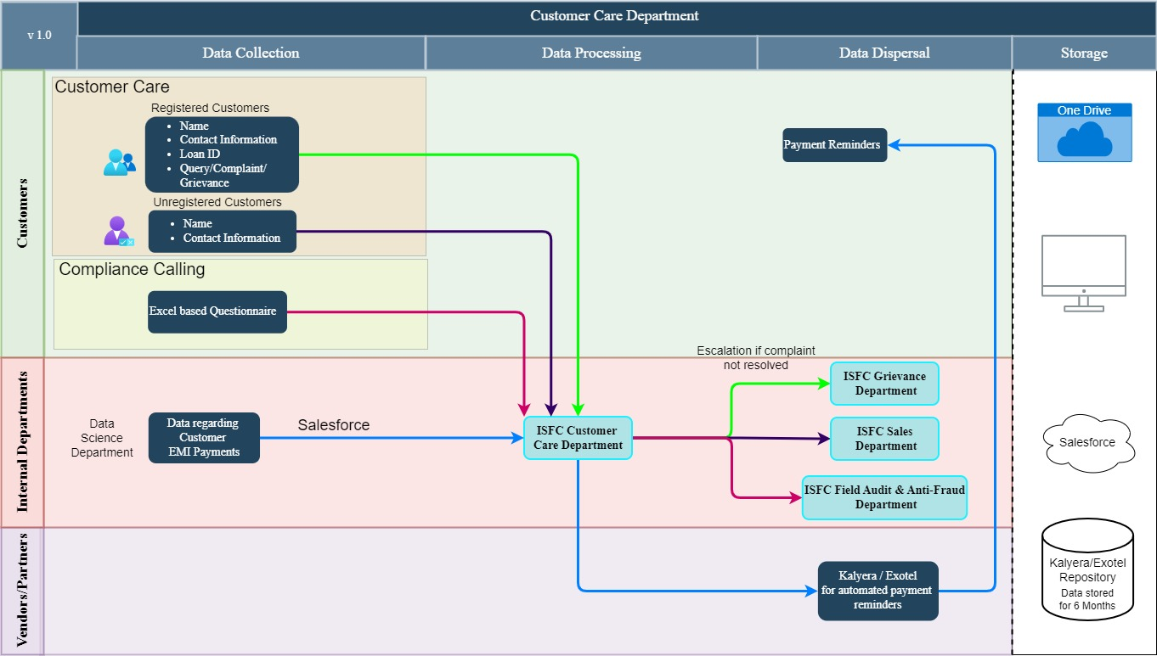
Data Flow Diagram (DFD)

Data Mapping and Inventory
S. No | Data Category | Description | Purpose | Data Owner | Storage Location | Data Classification* | Retention Period | Legal Obligation
1. | Customer Contact Details | Contact information of customers | Communication with customers and marketing efforts | Customer Care | Salesforce | PII/Sensitive | Not Defined | Consent  Required
2. | Loan Account Information | Information about customers' loan accounts, including balance, payment history, and account status | Assisting customers with loan-related inquiries and managing accounts | Customer Care | Salesforce | PII/Sensitive | Not Defined | Consent Required
3. | Customer Complaints | Details of customer complaints, including nature, resolution status, and any related correspondence | Resolving customer issues | Customer Care | Salesforce | PII/Sensitive | Not Defined | Consent Required
4. | Customer Feedback | Feedback and opinions provided by customers | Measuring customer satisfaction and identifying areas for improvement | Customer Care | Salesforce | PII/Sensitive | Not Defined | Consent Required
5. | Customer Interaction Logs | Records of interactions between customers and customer care representatives | Documenting customer inquiries, complaints, and resolutions | Customer Care | Salesforce | PII/Sensitive | Not Defined | Consent Required
6. | Compliance Checks | Checklist based opinions provided by customers | Gathering information for field audit and anti-fraud team | Customer Care | Excel/One Drive | PII/Restricted | Not Defined | Consent Required
*Refer Appendix A

Recommendations
- Consent Management and Documentation:
- Ensure that consent is obtained for data collection during compliance calls and that data sharing with the Field Audit & Anti-Fraud team follows DPDPA requirements.
- Implement robust consent management processes for handling customer data, ensuring clear consent is obtained for data processing activities.
- Document and maintain records of customer consent for data processing to demonstrate compliance with DPDPA requirements.

- Secure Handling of Customer Data:
- Classify and label customer data based on sensitivity and ensure appropriate access controls are in place.

- Training and Development:
- Include data protection protocols in training programs for new hires to ensure compliance.
- Provide ongoing training and development opportunities for existing staff to stay updated on regulatory changes and best practices.

- Implement Data Retention Policies:
- Define clear data retention periods for different types of customer data.
- Regularly review and update data retention policies to ensure compliance with DPDPA retention requirements and minimize the risk of retaining data beyond necessary periods.

Conclusion
In conclusion, the assessment of the customer care department of ISFC has identified areas for enhancing data protection, compliance with DPDPA. The recommendations provided offer guidance for streamlining data handling procedures and strengthen security measures.
Moving forward, it is imperative for ISFC to prioritize the adoption of best practices in data protection and compliance management. By fostering a culture of compliance, investing in staff training, and regularly reviewing and updating policies, ISFC can safeguard customer data, enhance operational efficiency, and maintain a competitive edge in the market.

Appendices

Appendix A
Data Classification | Definition
Sensitive Data | Information that, if disclosed, altered, or destroyed without authorization, could cause significant harm to an individual, organization, or entity. This often includes financial records, medical information, and PII.
Restricted Data | Highly sensitive data tightly controlled due to legal, regulatory, or contractual requirements. Access is limited to authorized personnel, and any unauthorized disclosure may result in severe consequences.
Private Data | Information considered confidential and intended solely for specific individuals or groups within an organization. It requires protection from unauthorized access to maintain privacy and uphold confidentiality agreements.
Confidential Data | Privileged or proprietary information of an organization requiring protection from unauthorized access, disclosure, or alteration.
Public Data | Information that is freely available and accessible to the general public without restrictions or limitations. It does not contain sensitive or confidential information and can be openly accessed and used for various purposes such as research, analysis, and public interest initiatives.
PII (Personally Identifiable Information) | Data that can identify, contact, or locate an individual, either alone or in combination with other information. For example - names, addresses, official identifiers (Aadhar, Pan, DL, biometrics, etc).
Non-PII | Data that, while not personally identifiable, however may still require protection due to its sensitivity or confidentiality. This may include corporate financial information, proprietary research data, or internal communications.

----------------------------------------End of Report for Customer Care-------------------------------------------

